Program 4 Design

Overview
The purpose of this program is to automate a movie inventory tracking system. It will allow a user to borrow, return, and view movies, as well as see the user’s own history of transactions.
Class Structure:
Movies Class
Main movies abstract class, Comedy, Drama, and Classics all inherit from Movie. Class members include Genre, Stock, Director, Title, and Year. Classic will have new derived class members consisting of Major Actor, Release Month, and Release Year.
Customer Class
Class members are customer ID, first name, last name, and transaction history.
Transaction Class
Abstract for derived classes with functions for commands such as B, R, H, and L.
Hash Table Class
General purpose hash table for Movies and Customer Transactions to be stored.
Operations Class
Functions to read all text files and instantiate movies, customers, and transactions.
Database Class
Store and modifies the movie and customer transaction hash tables.
The main program will call an instance of an Operations object, with the object you will be able to call readMovies(), to read all the movies from the text files into the movie hash table, readCustomer(), to read all customer info into the customer hash table, and readTransaction(), to read and execute all the transactions which will modify the movie stock in the movie hash table and modify the coinciding customer history.
The input for the program will be three text files. First, a file containing the data of the movie, such as things like movie genre, title, director, year made, and more. Second, a file containing customer data, including each customer’s unique identifier number, as well as their first and last name. Lastly, a file containing the commands for the program to be tested with. It consists of input commands like B(Borrow), R(return), L(list), and H(history), as well as some invalid inputs like X or Y to test the error handling capabilities. Followed by the command is the user’s unique identifier number and the classification of movie along with its data.
The expected program behavior is for it to execute all the commands properly, as well as handle erroneous inputs gracefully.
Possible errors could consist of a user inputting a genre of movie that does not exist within the program, inputting movie data incorrectly, using the incorrect user identification number, borrowing a movie when the stock is empty, returning a movie that the user does not currently have, and more we will discover in testing.

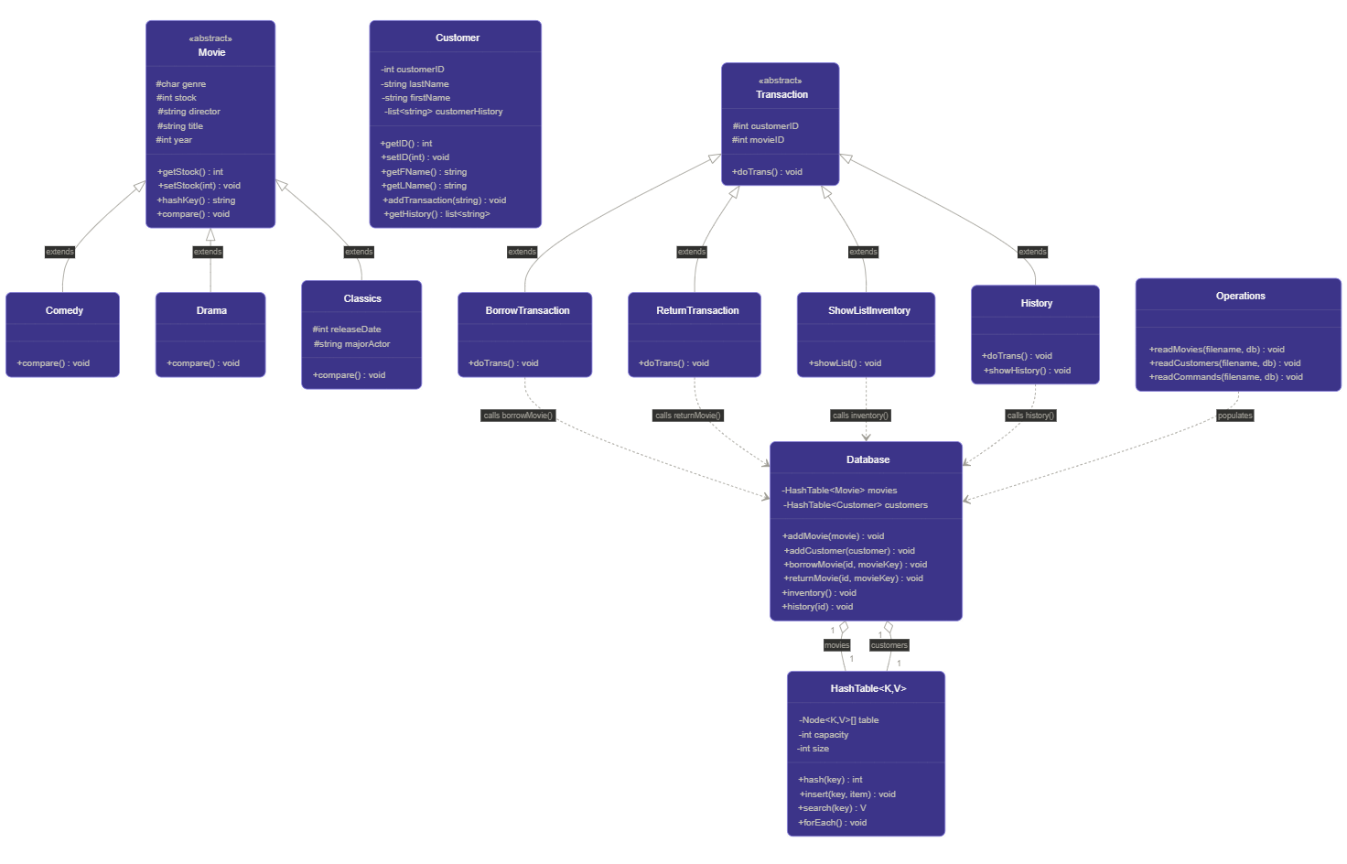
Class Diagram

Class Description
Movies.h
The abstract parent of all movies. It holds the data for every movie and declares the operations that differ by type as pure virtual, so the Database can store every movie uniformly.
Data members:
char Genre
int Stock
string Director
string Title
int Year
Member Functions:
virtual int getStock() = 0
virtual void setStock(int newStock) = 0
virtual string hashKey() = 0
virtual void compare() = 0
Comedy (Derived from Movie)
Member Functions:
- compare() – implements compare with sort order (Title, then Year)
Drama (Derived from Movie)
Member Functions:
- compare() – implements compare with sort order (Director, then Title)
Classics (Derived from Movie)
Extended Data Members:
int releaseDate
String majorActor
Member Functions:
- compare() – implements compare with sort order (Release Date, then Major Actor)

Customer.h
Represents one registered customer and owns that customer’s transaction history.
Data members:
int customerID
string lastName
string firstName
list<string> customerHistory

Member Functions:
int getID() – Returns ID of a customer.
void setID() – Sets ID of a customer.
string getFName() – Returns first name of a customer.
string getLName() – Returns last name of a customer.
void addTransaction() – Pushes transaction to history stack.
stack<string> getHistory() – Returns transaction history.

HashTable.h
A custom, generic hash table. Resolves collisons with quadratic probing.
Data members:
Node<K,V>[] table
Int capacity
Int size
Member Functions:
Hash(key) – Maps a key to an index.
Insert(key, item) – Inserts an item into the table.
Search(key) – Returns an item from the table.
forEach() – Visits every index.

Database.h
The central controller. It owns the inventory and customer registries and provides one method per supported operation.
Data members:
Movies: HashTable<Movies> - Hash table of movies, keyed by movie identity.
Customers: HashTable<Customer> - Hash table of customers, keyed by customer identity.
Member Functions:
- addMovie(movie) – inserts a parsed movie into the Movies HashTable, merging stock if it already exists.
- addCustomer(customer) – inserts a customer object into the Customer HashTable
- borrowMovie(id, movieKey) – performs a borrow if customer id and movie key exist and stock is available.
- returnMovie(id, movieKey) – performs a return if a customer previously borrowed that movie.
- inventory() – returns all current inventory.
- history(id) – prints one customer’s history of transactions.
Pseudocode (borrowMovie()):
Function borrow(id, movieKey):
customer = customers.find(id);
If (customer == null):
cerr << “Customer not found”; return;
movie = movies.find(movieKey);
if (movie == null):
cerr << “Movie not found”; return;
if(movie.stock == 0):
cerr << “Movie out of stock”; return;
movie.setStock(movie.stock – 1);
customer.addTransaction(new BorrowTransaction(movie));

Pseudocode (returnMovie()):
Function returnMovie(id, movieKey):
customer = customers.find(id);
movie = movies.find(movieKey);
If (customer == null):
cerr << “Customer not found”; return;
if (movie == null):
cerr << “Movie not found”; return;
If customer has no outstanding movie:
cerr << “Item not borrowed”; return;
movie.setStock(movie.stock + 1);
customer.addTransaction(new ReturnTransaction(movie));

Transaction.h
The abstract parent for a single recorded action. It stores what was acted on and when, and declares the action as pure virtual so each subtype names itself.
Data members:
int customerID
Int movieID
Member Functions:
doTrans() = 0

BorrowTransaction & ReturnTransaction (Derived from Transaction.h)
These subtypes contain no extra data. Inheritance is used here as per the specification requirements.
Member Functions:
- BorrowTransaction – implements doTrans() to use borrow from database.h
- ReturnTransaction – implements doTrans() to use return from database.h

Show List Inventory (Derived from Transaction)
Member Function:
showList – uses inventory from database.h
History – Implements doTrans() to return “History”
showHistory – calls history() from database.h

Operations.h
Responsible for file input. Opens each file, parses each one at a time, builds the appropriate object (or command), and forwards it to Database.
Member Functions:
- readMovies(filename, Database) – parses the movie text file and inserts the movie to movieDatabase
- readCustomers(filename, Database) – parses the customers text file and inserts to customerDatabase into it.
- readCommands(filename, Database) - parses the commands text file and calls functions from transaction.h to execute the commands
Pseudocode (readCommands(filename, Database)):
Function readCommands(filename, Database):
For each line in the file:
Action = first token;
Switch (action)
Case I: showList();
Case H: showHistory();
Case B: borrowTransaction();
Case R: returnTransaction();
Default: cerr << “invalid action code”;

Implementation and Test Plan
We plan to start by implementing the Movie class and its inherited Classic, Drama, and Comedy to ensure that it stores the data correctly. Immediately after we will implement Customer.h to store customer ID, name, and transaction history. We will then go onto implement our own general purpose hash table that will allows us to store any class into the hash table and resolve collisions efficiently. After implementing the hashtable we will use them in database.h to store customer objects and movie objects, allowing for quick lookups and easy access. Database.h will be the central access point for making any changes to movie inventory and customer history. We will then implement transaction.h and the inherited borrow, return, list, and history functions, these will all use doTrans() to call functions from database.h to reflect the changes of the transaction onto the database. Finally, we will implement operation.h which is practically a wrapper class to only allow you to use three functions within the driver: readMovie() which will read the movie textfile and add them to the movieDatabse, readCustomer() to read all customer ID’s and names from the text file to add to the customerDatabase, and readCommand() to read all the commands from the text file and use transaction.h to execute all the commands.
Testing Strategy:
- Unit testing: each class is exercised on its own first — e.g. insert/find on HashTable, compareTo on each movie type, hasOutstanding on Customer.
- End to End testing: run the program on the provided compare output against hand traced expectation results.
- Boundary testing: verify behaviour at stock 0 (borrow rejected), at non-default stock values, and with a Classic title that has multiple actor editions.

